Ponce Martin 10371381 Date 27/08/2014

Family name Given name Student number

**ENS1161 Computer Fundamentals**

**Test 4**

|  |  |  |  |  |
| --- | --- | --- | --- | --- |
|  |  |  |  |  |
|  |  |  |  |  |
|  | 1 |  |  | 1 |
|  | 1 |  |  |  |
|  |  | 1 | 1 |  |

**w**

**x**

**y**

**z**

(a) Draw a Karnaugh map for each of P = y' z' + x z and Q = w x' z + x y' z' + w' x y z'

|  |  |  |  |  |
| --- | --- | --- | --- | --- |
|  |  |  |  |  |
|  | 1 |  |  |  |
|  | 1 | 1 | 1 |  |

**x**

**y**

**z**

P: Q:

(b) Find a **minimal** sum of products for each of the Karnaugh maps:



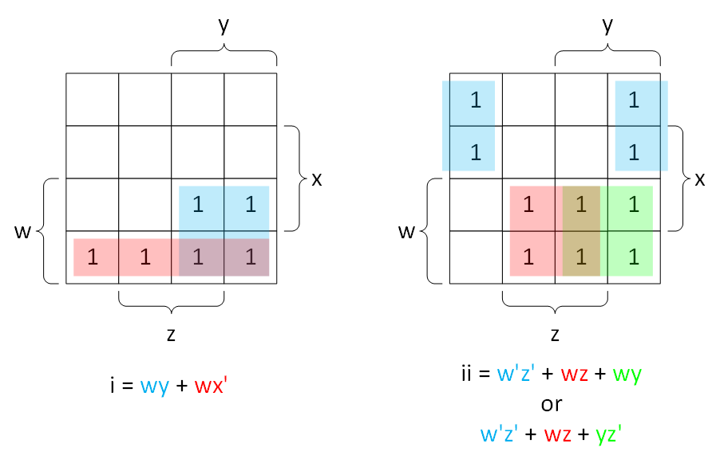

(c) A Boolean function M(x, y, z) is

defined by truth table shown:  
 

(i) Express M as a **complete** sum of products:

|  |  |  |  |  |
| --- | --- | --- | --- | --- |
|  |  |  |  |  |
|  |  | 1 |  | 1 |
|  |  | 1 |  | 1 |

**x**

**y**

**z**

M = x'y'z + x'yz' + xy'z + xyz'

(ii) Draw a Karnaugh map for M.

(iii) Express M as a **minimal** sum of products.

M = y'z + yz'

[2 + 4 + 4 = 10 marks]